Apollonius' Theorem
# Source: AI Source: Provided by: [Data Path: Persons Table -> ID Column: 1, Name_En Column: Motasem Essam] -> From: [ChatGPT] on [7/25/2026]
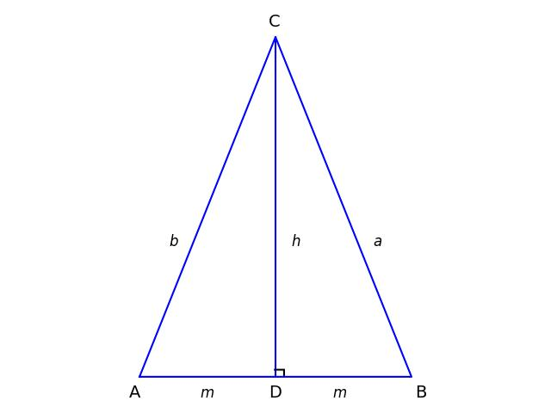
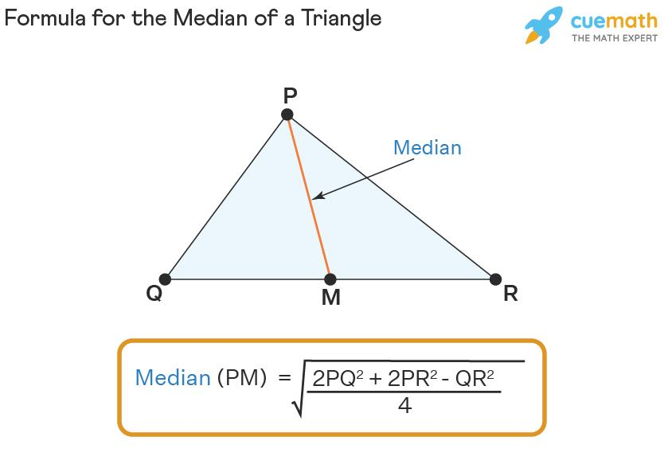
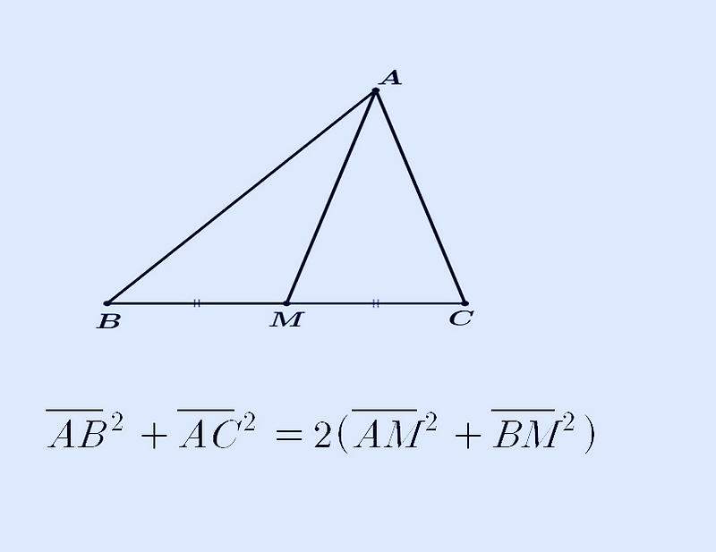

Definition
# Source: AI Source: Provided by: [Data Path: Persons Table -> ID Column: 1, Name_En Column: Motasem Essam] -> From: [ChatGPT] on [7/25/2026]
Apollonius' Theorem is a theorem in triangle geometry that relates the lengths of the three sides of a triangle to the length of a median.
If $AD$is a median of $△ABC$, then $D$is the midpoint of $BC$, so:
$$BD=DC=\frac{BC}{2}$$
Apollonius' Theorem states:
$$\boxed{AB^{2}+AC^{2}=2\left(AD^{2}+BD^{2}\right)}$$
Since $BD=\frac{BC}{2}$:
$$\boxed{AB^{2}+AC^{2}=2AD^{2}+\frac{BC^{2}}{2}}$$
Equivalently,
$$\boxed{AD^{2}=\frac{AB^{2}+AC^{2}}{2}-\frac{BC^{2}}{4}}$$

Simple Definition
# Source: AI Source: Provided by: [Data Path: Persons Table -> ID Column: 1, Name_En Column: Motasem Essam] -> From: [ChatGPT] on [7/25/2026]
Apollonius' Theorem gives the length of a median of a triangle from the lengths of its three sides.
In other words:
The square of a median equals half the sum of the squares of the two adjacent sides minus one-quarter of the square of the opposite side.

Fundamental Configuration
# Source: AI Source: Provided by: [Data Path: Persons Table -> ID Column: 1, Name_En Column: Motasem Essam] -> From: [ChatGPT] on [7/25/2026]
Consider $△ABC$, with median $AD$:
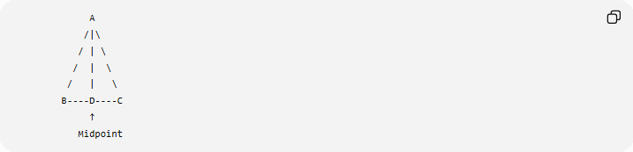
A
/|\
/ | \
/ | \
/ | \
B----D----C
↑
Midpoint
Because $AD$is a median:
$$BD=DC$$
If:
$$BC=a, AC=b, AB=c, AD=m_{a}$$
then:
$$BD=DC=\frac{a}{2}$$
Apollonius' Theorem becomes:
$$\boxed{b^{2}+c^{2}=2m_{a}^{2}+\frac{a^{2}}{2}}$$
Therefore:
$$\boxed{m_{a}=\frac{1}{2}\sqrt{2b^{2}+2c^{2}-a^{2}}}$$

Standard Formula
# Source: AI Source: Provided by: [Data Path: Persons Table -> ID Column: 1, Name_En Column: Motasem Essam] -> From: [ChatGPT] on [7/25/2026]
For a triangle with:
$$BC=a, CA=b, AB=c$$
and median $AD=m_{a}$:
$$\boxed{m_{a}=\frac{1}{2}\sqrt{2b^{2}+2c^{2}-a^{2}}}$$
Similarly, the other two medians are:
$$\boxed{m_{b}=\frac{1}{2}\sqrt{2a^{2}+2c^{2}-b^{2}}}$$
and
$$\boxed{m_{c}=\frac{1}{2}\sqrt{2a^{2}+2b^{2}-c^{2}}}$$
where:
- $m_{a}$is the median to side $a$
- $m_{b}$is the median to side $b$
- $m_{c}$is the median to side $c$

Median to Side $BC$
# Source: AI Source: Provided by: [Data Path: Persons Table -> ID Column: 1, Name_En Column: Motasem Essam] -> From: [ChatGPT] on [7/25/2026]
Suppose:
$$AD=m_{a}$$
and $D$is the midpoint of $BC$.
Therefore:
$$BD=DC=\frac{a}{2}$$
Apollonius' Theorem says:
$$AB^{2}+AC^{2}=2\left(AD^{2}+BD^{2}\right)$$
Substitute:
$$AB=c, AC=b, BD=\frac{a}{2}$$
giving:
$$c^{2}+b^{2}=2\left(m_{a}^{2}+\frac{a^{2}}{4}\right)$$
Expand:
$$b^{2}+c^{2}=2m_{a}^{2}+\frac{a^{2}}{2}$$
Rearrange:
$$2m_{a}^{2}=b^{2}+c^{2}-\frac{a^{2}}{2}$$
Thus:
$$\boxed{m_{a}^{2}=\frac{b^{2}+c^{2}}{2}-\frac{a^{2}}{4}}$$
and:
$$\boxed{m_{a}=\frac{1}{2}\sqrt{2b^{2}+2c^{2}-a^{2}}}$$

Example 1 — Finding a Median
# Source: AI Source: Provided by: [Data Path: Persons Table -> ID Column: 1, Name_En Column: Motasem Essam] -> From: [ChatGPT] on [7/25/2026]
Suppose a triangle has:
$$AB=5, AC=7, BC=8$$
Find the median from $A$.
Here:
$$c=5, b=7, a=8$$
Use:
$$m_{a}=\frac{1}{2}\sqrt{2b^{2}+2c^{2}-a^{2}}$$
Substitute:
$$m_{a}=\frac{1}{2}\sqrt{2\left(7^{2}\right)+2\left(5^{2}\right)-8^{2}} \\ =\frac{1}{2}\sqrt{98+50-64} \\ =\frac{1}{2}\sqrt{84} \\ =\sqrt{21}$$
Therefore:
$$\boxed{m_{a}=\sqrt{21}}$$
approximately:
$$\boxed{m_{a}≈4.58}$$

Example 2 — Finding a Missing Side
# Source: AI Source: Provided by: [Data Path: Persons Table -> ID Column: 1, Name_En Column: Motasem Essam] -> From: [ChatGPT] on [7/25/2026]
Suppose:
$$AB=13, AC=15$$
and the median from $A$has length:
$$AD=14$$
Find $BC$.
Use:
$$AB^{2}+AC^{2}=2AD^{2}+\frac{BC^{2}}{2}$$
Substitute:
$${13}^{2}+{15}^{2}=2\left({14}^{2}\right)+\frac{BC^{2}}{2} \\ 169+225=392+\frac{BC^{2}}{2} \\ 394=392+\frac{BC^{2}}{2} \\ 2=\frac{BC^{2}}{2}$$
Therefore:
$$BC^{2}=4$$
so:
$$\boxed{BC=2}$$

Example 3 — Equilateral Triangle
# Source: AI Source: Provided by: [Data Path: Persons Table -> ID Column: 1, Name_En Column: Motasem Essam] -> From: [ChatGPT] on [7/25/2026]
Consider an equilateral triangle with side length $s$.
Every median has length:
$$m=\frac{\sqrt{3}}{2}s$$
Using Apollonius' formula:
$$m=\frac{1}{2}\sqrt{2s^{2}+2s^{2}-s^{2}} \\ =\frac{1}{2}\sqrt{3s^{2}} \\ \boxed{m=\frac{\sqrt{3}}{2}s}$$
So Apollonius' Theorem also gives the familiar median/altitude formula for an equilateral triangle.

Relationship with the Median
# Source: AI Source: Provided by: [Data Path: Persons Table -> ID Column: 1, Name_En Column: Motasem Essam] -> From: [ChatGPT] on [7/25/2026]
A median connects a vertex of a triangle to the midpoint of the opposite side.
For:
$$D∈BC$$
the segment $AD$is a median exactly when:
$$\boxed{BD=DC}$$
Therefore, Apollonius' Theorem specifically concerns a median, not an arbitrary cevian.
This is an important distinction from Stewart's Theorem, which applies to a general cevian.

Apollonius' Theorem and Stewart's Theorem
# Source: AI Source: Provided by: [Data Path: Persons Table -> ID Column: 1, Name_En Column: Motasem Essam] -> From: [ChatGPT] on [7/25/2026]
These two theorems are closely related.
Stewart's Theorem
For a general cevian $AD$:
$$BD=m, DC=n, BC=a$$
Stewart's Theorem gives:
$$\boxed{b^{2}m+c^{2}n=a\left(d^{2}+mn\right)}$$
where:
$$AD=d$$
Apollonius' Theorem
For a median:
$$m=n=\frac{a}{2}$$
Substituting this condition into Stewart's Theorem produces Apollonius' Theorem.
Therefore:
$$\boxed{\text{Apollonius’ Theorem is a special case of Stewart’s Theorem}}$$
This is one of the most important relationships between the two theorems.

Apollonius' Theorem and Pythagorean Theorem
# Source: AI Source: Provided by: [Data Path: Persons Table -> ID Column: 1, Name_En Column: Motasem Essam] -> From: [ChatGPT] on [7/25/2026]
Apollonius' Theorem can also be viewed as a generalization of a relationship involving a median.
For a right triangle, suppose $BC$is the hypotenuse and $AD$is the median to the hypotenuse.
Then:
$$AB^{2}+AC^{2}=BC^{2}$$
From Apollonius:
$$AB^{2}+AC^{2}=2AD^{2}+\frac{BC^{2}}{2}$$
Therefore:
$$BC^{2}=2AD^{2}+\frac{BC^{2}}{2}$$
which gives:
$$\frac{BC^{2}}{2}=2AD^{2}$$
so:
$$\boxed{AD=\frac{BC}{2}}$$
Thus, in a right triangle:
The median to the hypotenuse has length equal to half the hypotenuse.

Sum of the Squares of the Three Medians
# Source: AI Source: Provided by: [Data Path: Persons Table -> ID Column: 1, Name_En Column: Motasem Essam] -> From: [ChatGPT] on [7/25/2026]
Apollonius' Theorem can also be used to derive an important identity involving all three medians.
For side lengths $a,b,c$:
$$m_{a}^{2}=\frac{2b^{2}+2c^{2}-a^{2}}{4} \\ m_{b}^{2}=\frac{2a^{2}+2c^{2}-b^{2}}{4} \\ m_{c}^{2}=\frac{2a^{2}+2b^{2}-c^{2}}{4}$$
Adding them:
$$m_{a}^{2}+m_{b}^{2}+m_{c}^{2}=\frac{3}{4}\left(a^{2}+b^{2}+c^{2}\right)$$
Therefore:
$$\boxed{m_{a}^{2}+m_{b}^{2}+m_{c}^{2}=\frac{3}{4}\left(a^{2}+b^{2}+c^{2}\right)}$$
This is another important consequence of Apollonius' Theorem.

Vector Interpretation
# Source: AI Source: Provided by: [Data Path: Persons Table -> ID Column: 1, Name_En Column: Motasem Essam] -> From: [ChatGPT] on [7/25/2026]
Apollonius' Theorem also has a natural vector interpretation.
Let $D$be the midpoint of $BC$. If position vectors are used:
$$\vec{D}=\frac{\vec{B}+\vec{C}}{2}$$
The median vector from $A$is:
$$\vec{AD}=\frac{\vec{AB}+\vec{AC}}{2}$$
Taking squared lengths leads to the same relationship:
$$\boxed{AB^{2}+AC^{2}=2AD^{2}+\frac{BC^{2}}{2}}$$
Thus the theorem is also connected to the parallelogram law and vector geometry.

Important Characteristics

1. It concerns a median
# Source: AI Source: Provided by: [Data Path: Persons Table -> ID Column: 1, Name_En Column: Motasem Essam] -> From: [ChatGPT] on [7/25/2026]
The segment must connect a vertex to the midpoint of the opposite side.

2. It uses squared lengths
# Source: AI Source: Provided by: [Data Path: Persons Table -> ID Column: 1, Name_En Column: Motasem Essam] -> From: [ChatGPT] on [7/25/2026]
The theorem relates:
$$AB^{2}, AC^{2}, BC^{2}, AD^{2}$$
rather than the lengths directly.

3. It works for any triangle
# Source: AI Source: Provided by: [Data Path: Persons Table -> ID Column: 1, Name_En Column: Motasem Essam] -> From: [ChatGPT] on [7/25/2026]
The triangle may be:
- acute
- right
- obtuse
- scalene
- isosceles
- equilateral
provided the required side lengths form a valid triangle.

4. It can find a median
# Source: AI Source: Provided by: [Data Path: Persons Table -> ID Column: 1, Name_En Column: Motasem Essam] -> From: [ChatGPT] on [7/25/2026]
Given all three sides:
$$\boxed{m_{a}=\frac{1}{2}\sqrt{2b^{2}+2c^{2}-a^{2}}}$$

5. It can find a missing side
# Source: AI Source: Provided by: [Data Path: Persons Table -> ID Column: 1, Name_En Column: Motasem Essam] -> From: [ChatGPT] on [7/25/2026]
If the median and two appropriate sides are known, the equation can be rearranged to find the remaining side.

Common Mistake
# Source: AI Source: Provided by: [Data Path: Persons Table -> ID Column: 1, Name_En Column: Motasem Essam] -> From: [ChatGPT] on [7/25/2026]
A common mistake is to use the theorem for an arbitrary point $D$on $BC$.
For example:

A
|\
| \
| \
B---D---C
The theorem does not automatically apply.
You must know that:
$$\boxed{BD=DC}$$
because $D$must be the midpoint of $BC$.
If $BD≠DC$, use Stewart's Theorem instead.

Classification
# Source: AI Source: Provided by: [Data Path: Persons Table -> ID Column: 1, Name_En Column: Motasem Essam] -> From: [ChatGPT] on [7/25/2026]
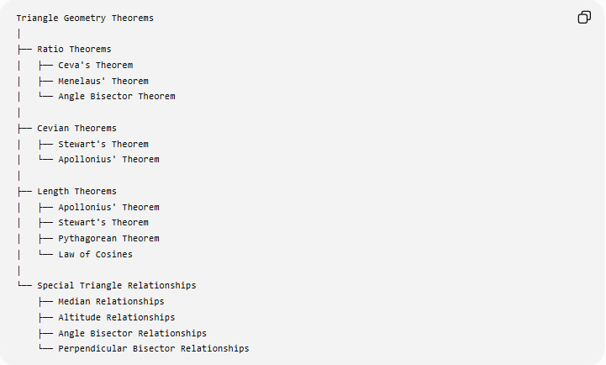
Triangle Geometry Theorems
│
├── Ratio Theorems
│ ├── Ceva's Theorem
│ ├── Menelaus' Theorem
│ └── Angle Bisector Theorem
│
├── Cevian Theorems
│ ├── Stewart's Theorem
│ └── Apollonius' Theorem
│
├── Length Theorems
│ ├── Apollonius' Theorem
│ ├── Stewart's Theorem
│ ├── Pythagorean Theorem
│ └── Law of Cosines
│
└── Special Triangle Relationships
├── Median Relationships
├── Altitude Relationships
├── Angle Bisector Relationships
└── Perpendicular Bisector Relationships
The classification can overlap because Apollonius' Theorem is simultaneously a median theorem, a length theorem, and a special case of Stewart's Theorem.

Comparison with Related Theorems
# Source: AI Source: Provided by: [Data Path: Persons Table -> ID Column: 1, Name_En Column: Motasem Essam] -> From: [ChatGPT] on [7/25/2026]
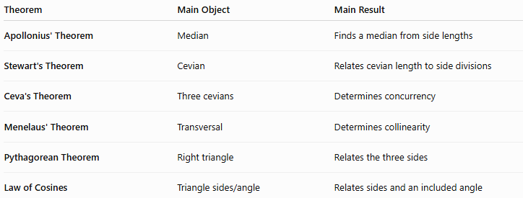
Theorem | Main Object | Main Result
Apollonius' Theorem | Median | Finds a median from side lengths
Stewart's Theorem | Cevian | Relates cevian length to side divisions
Ceva's Theorem | Three cevians | Determines concurrency
Menelaus' Theorem | Transversal | Determines collinearity
Pythagorean Theorem | Right triangle | Relates the three sides
Law of Cosines | Triangle sides/angle | Relates sides and an included angle
The central distinction is:
$$\boxed{\text{Apollonius}→\text{Median Length}} \\ \boxed{\text{Stewart}→\text{General Cevian Length}} \\ \boxed{\text{Ceva}→\text{Concurrency}} \\ \boxed{\text{Menelaus}→\text{Collinearity}}$$

Key Formula Summary
# Source: AI Source: Provided by: [Data Path: Persons Table -> ID Column: 1, Name_En Column: Motasem Essam] -> From: [ChatGPT] on [7/25/2026]
For $△ABC$:
$$BC=a, CA=b, AB=c$$
and median $AD=m_{a}$:
$$\boxed{b^{2}+c^{2}=2m_{a}^{2}+\frac{a^{2}}{2}}$$
Therefore:
$$\boxed{m_{a}^{2}=\frac{2b^{2}+2c^{2}-a^{2}}{4}}$$
and:
$$\boxed{m_{a}=\frac{1}{2}\sqrt{2b^{2}+2c^{2}-a^{2}}}$$
Similarly:
$$\boxed{m_{b}=\frac{1}{2}\sqrt{2a^{2}+2c^{2}-b^{2}}} \\ \boxed{m_{c}=\frac{1}{2}\sqrt{2a^{2}+2b^{2}-c^{2}}}$$
For all three medians:
$$\boxed{m_{a}^{2}+m_{b}^{2}+m_{c}^{2}=\frac{3}{4}\left(a^{2}+b^{2}+c^{2}\right)}$$

Conclusion
# Source: AI Source: Provided by: [Data Path: Persons Table -> ID Column: 1, Name_En Column: Motasem Essam] -> From: [ChatGPT] on [7/25/2026]
Apollonius' Theorem is a fundamental triangle-length theorem concerning medians. It establishes a precise relationship between the three side lengths of a triangle and the length of a median:
$$\boxed{AB^{2}+AC^{2}=2AD^{2}+\frac{BC^{2}}{2}}$$
Its most useful form is:
$$\boxed{AD=\frac{1}{2}\sqrt{2AB^{2}+2AC^{2}-BC^{2}}}$$
It is especially important because it connects median geometry, side lengths, Stewart's Theorem, and the Pythagorean relationship.

